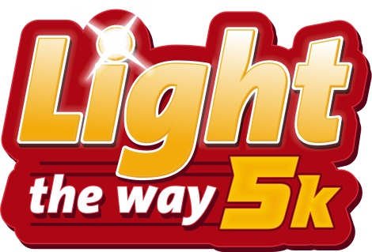

Light the Way 5K Run/Walk
A run/walk through Dollywood’s 5 Million Christmas lights
To benefit Keep Sevier Beautiful and Share It Forward

Friday, November 12, 2021

This 5K draws thousands of runners from across the nation for the unique opportunity to run through the Dollywood theme park at night and through behind-the-scenes areas.

Light the Way 5K Title Sponsor - $5,000 (One Sponsorship Available – TAKEN)
This sponsorship offers the highest degree of promotional sponsorship with the following benefits.
- Listed as the Top Sponsor with logo on event website, Facebook and t-shirt
- Exclusive banner at Main Stage of awards ceremony with business logo
- Business logo and link to website on event website, Keep Sevier Beautiful website, race
registration website and Dollywood email blast
- Listed as the title sponsor with logo on advertising and collateral materials, including newspaper ad, flyers and posters
- Opportunity to speak at race start and awards ceremony
- Opportunity to present overall race winners
- Opportunity to have a booth at registration
- Business name acknowledged in race announcements night of race
- Promotional opportunities in race packet
- Ten complimentary entries for race
- Ten complimentary Dollywood admission tickets
- UNLIMITED signage at event (Sponsor provided)

Platinum Sponsor - $3,000 (two sponsorships available)
Sponsorship is featured just below the Title Sponsor Level in descending size and order.
- Listed as Platinum Sponsor with logo on event website, Facebook and t-shirt
- Business logo and link to website on event website, Keep Sevier Beautiful website and race
registration website
- Listed as platinum sponsor with logo on advertising and collateral materials, including newspaper ad, flyers and posters
- Business name acknowledged in race announcements night of race
- Promotional opportunities in race packet
- Eight complimentary entries
- Eight complimentary Dollywood admission tickets
- One exclusive sign along course (provided by sponsor)

Gold Sponsor - $1,500 (Six Sponsorships Available)
Sponsorship is featured just below the above in descending size and order.
- Listed as Gold Sponsor with business logo on event website, Facebook and t-shirt
- Business logo on event website, Keep Sevier Beautiful website, and race registration website
- Listed as Gold Sponsor with logo on advertising and collateral materials (newspaper ad, flyers and posters)
- Business name acknowledged in race announcements night of race
- Promotional opportunities in race packet
- Six complimentary entries
- Six complimentary Dollywood admission tickets

Silver Sponsor - $1,000
Sponsorship is featured just below the above in descending size and order.
- Listed as Silver Sponsor with business logo on event website, Facebook and t-shirt
- Business logo and link to website on event website, Keep Sevier Beautiful website, and
race registration website
- Listed as sponsor on advertising materials (newspaper ad, flyers and posters)
- Business name acknowledged in race announcements night of race
- Promotional opportunities in race packet
- Four complimentary entries
- Four complimentary Dollywood admission tickets

Bronze Sponsor- $500
Sponsorship is featured just below the above in descending size and order.
- Listed as Bronze Sponsor on event website and Facebook
- Business logo and link to website on event website, Keep Sevier Beautiful website, and
race registration website
- Listed as sponsor on advertising materials (newspaper ad, flyers and posters)
- Business name acknowledged in race announcements night of race
- Promotional opportunities in race packet
- Two complimentary entries
- Two complimentary Dollywood admission tickets

Mile Marker Sponsor/ Water Stop Sponsor- $100
Sponsorship is featured just below the above in descending size and order.
- Company logo on sign (provided by event) at mile marker or water stop
- Business name acknowledged in race announcements night of race.

If you are interested in supporting this event or have any additional questions, please call Lisa Bryant at Keep Sevier Beautiful at (865) 774-6677 or email lbryant@keepsevierbeautiful.org

